StayMatch Web Application

Business Requirements Document

Project: StayMatch Web Application

Author(s): Prathima S R, Shubham Mishra, Rahul Mendes, Akshat, Ajay, Kritika Agarwal, Daulet, Dhruv

Table of Contents

**1.** **Project Overview** 3

**2.** **Document Information** 3

2.1 Audience 3

**3.** **Business Opportunity** 3

3.1 Project Overview and Background 3

3.2 Current State Analysis 4

3.3 Future State Objectives 4

3.4 Business Domain Model and Stakeholders 4

**4.** **Business Requirements** 4

4.1 Details of Business Requirements 5

**5.** **Non-Functional Requirements** 6

**6.** **External Data Feeds** 7

**7.** **Business Risks** 7

# **Project Overview**

This document outlines the necessary business and user requirements for StayMatch web applications, which will serve as the foundation for the project's various activities. These include:

* Identifying stakeholders
* Introducing business and user requirements
* Creating test plans and test specifications for them
* Developing solutions for project tasks
* Produce an application that will allow users to rent a place to stay, as well as rent it out for a small commission
* Determining when the project is complete
* Assessing the degree to which the project succeeded

# **Document Information**

## 2.1 Audience

|  |  |  |
| --- | --- | --- |
| Name | Business Group | Role |
| Tenants/Renters | Customer’s Service Department | Web Application Users |
| Landlords | Customer’s Service Department | Web Application Users |
| Brokers/Dealers | Customer’s Service Department | Web Application Users |
| Bank, Credit Card vendors | Marketing and Sales Team | Partner/Supplier |

## Business Opportunity

## Project Overview and Background

The majority of students struggle to manage their housing requirements, especially in terms of obtaining convenient and affordable housing. It can take a lot of time and effort to look for a home, get in touch with landlords, and negotiate a rent amount. Also, it might be difficult for students to split expenses like rent with their housemates. A new website called "StayMatch" will be created to solve these issues and make it easier for students to discover and rent housing. This website provides a simple user interface for finding available rentals and getting in touch with landlords. Students may choose the ideal housing option that meets their needs by using this user-friendly website, saving time and money in the process. Students may easily discover their next home with StayMatch, whether it's a single room or an entire house.

## Current State Analysis

Operating in a foreign education system promotes personal development only if the special challenges of foreign students are resolved. Every year students from all over the world apply for various courses in the USA and face the problem of finding student accommodation.

One should choose an accommodation that suits their needs and budget while keeping in mind inclusions like transportation, utilities, meals, and other supplemental services and costs. But it’s not as simple as it appears to be.In order to ease the process to find accommodation suitable to the student there led to the development of various accommodation applications, some of the examples are Zillow, Sulekha, AirBnb, Trulia, Apartments.com. StayMatch application's focus on catering to the needs of international students provides them with a convenient and efficient solution for their housing needs, which they may not find otherwise.The application provides easier access to students from all over the world to select their choice of place to stay in a foreign country. The application will provide access to the landlords to post the listing of their properties which can be viewed by the renters and they will be able to contact them. The project UI will be developed in React Js and backend API’s will be implemented in Python using Flask and the MongoDB will be used for data storage. The planning process for the application is currently underway, and the development of the project will span two semesters at Pace University.

## Future State Objectives

The objective is to create a web application that will be able to compete in the very crowded marketplace of rentals. The web application will provide an efficient and quick solution to all the renters across the globe. Landlords will also have an option to list their properties and make it available to the renters. The application will also connect the landlords with the renters and provide an easy way to occupy the Landlord’s properties for a specific duration of time. We will include the option of finding roommates for a specific renter as a future scope objective.

## Business Domain Model and Stakeholders

|  |
| --- |
| Stakeholders |
| Product Development Team |
| Support team |
| Marketing and Sales Team |
| Tenants and renters |
| Landlords,Property Owners and Brokers. |
| Advertising Media |
| Bank |
| Credit Card Venders |

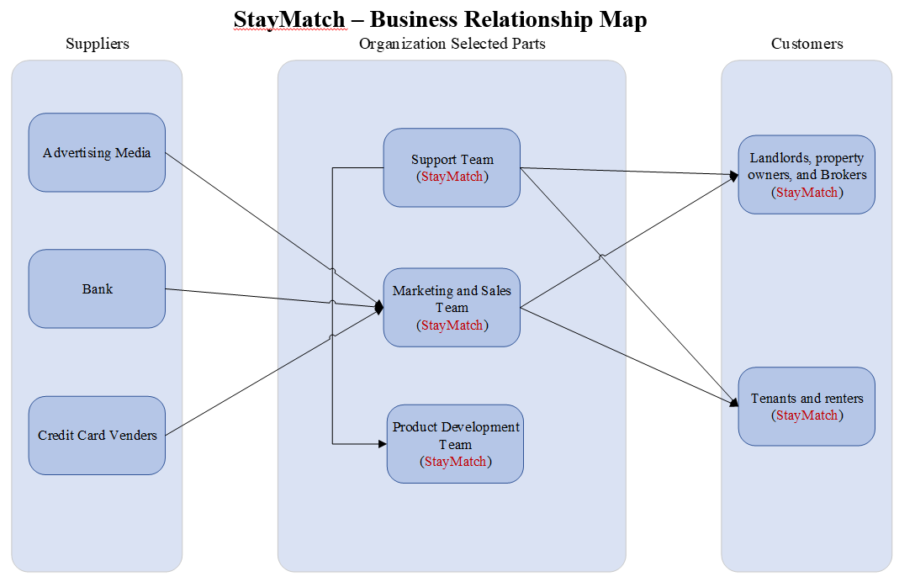

# **Business Requirements**

The primary users of the Cravings! application will be able to create the account and subscribe to various subscription plans that will indicate the number of items they will receive in each order. The portal will provide customers with a user-friendly interface that will allow them to create the custom box of different items from three major categories of products such as smoothies, beverages, and breakfast bowls. The application will also allow users to create the profile of the ingredients they dislike that will make their shopping experience more convenient and will allow them to save the time by scrolling through the items that contain the ingredients they like and eliminate the products that contain the ingredients they don’t like. The user will also be able to skip the deliveries without canceling the subscription, allowing the company to keep the customers without making them pay when they want to take a break, allowing Cravings! generate future profit.

## Details of Business Requirements – from BRM diagram – RCT from details of buss req – TEST IDEAS – DON’T SPEND MUCH TIME

* + 1. Marketing and Sales Team – Daulet (Done) Review - Shubham
       1. Ability to log in
       2. Ability to generate advertisement on StayMatch web application
       3. Ability to maintain content of an advertisement
       4. Ability to filter advertisement content
       5. Ability to advertisement up to date
       6. Ability to view and manage customer information
       7. Ability to process customer information to identify market trends
       8. Ability to understand product performance
       9. Ability to promote sponsored posts
       10. Ability to communicate within Marketing and Sales Team
    2. **Product Development Department - Akshat Review - Shubham**
       1. Ability to log in
       2. Ability to collaborate with other team members
       3. Ability to track progress
       4. Ability to perform user research
    3. **Customer Support Department Review - Shubham**
       1. Ability to respond effectively through the customer support page
       2. Ability to update the open ticket as closed or resolved
       3. Ability to provide the customers with ticket resolution
    4. **Subscribed Customers requirements** 
       1. Ability to Register on our web application(RL, RR)
       2. Ability to Fill the registration information correctly(RL, RR)
       3. Ability to Modify the created account information(RL, RR)
       4. Ability to Login and logout from the created account(RL, RR)
       5. Ability to Update the account information(RL, RR)
       6. Ability to Update the password with validations(RL, RR)
       7. Ability to Search for properties based on preferences ex: location. (RR)
       8. Ability to View property details (RR)
       9. Ability to Contact the landlord or property owners with the help of details given. (RR)
       10. Ability to Book viewings as well as save it for future references. (RR)
       11. Ability to List their properties(RL)
       12. Ability to Upload photos and property details. (RL)
       13. Ability to Set rental prices(RL)
       14. Ability to Manage Booking and enquiries. (RL)
       15. Ability to View property suggestions on HomePage(RR)
       16. Ability to View banners on homepage to understand the features provided by web application(RL, RR)

**where RL – Landlord/property owner**

**RR - Renter**

# **Non-Functional Requirements**

|  |  |
| --- | --- |
| **Category** | **Requirements** |
| **Usability** | The application GUI will provide a user-friendly intuitive design with all the features clearly displayed for the user |
| **Usability** | The application navigation will be self-explanatory by clear and concise descriptions and names of each section, as well as features will be clearly evident by proper location and naming |
| **Usability** | Accessibility will be supported for the disabled users as well |
| **Performance** | The application will be supported on different operating systems and browsers, and should not impact the user’s system capabilities |
| **Performance** | The application will be available for 24/7 without any interruptions, and regular maintenances will be scheduled to support the application |
| **Performance** | The application will support the concurrency where the users will be able to simultaneously browse the app, login & register, post rental properties, contact the landlords, view listing details |
| **Performance** | The application will have short response time to all requests and all the features should be available and not impacted by latency |
| **Security** | The application will use HTTPS protocols for any data exchanges. |
| **Database** | The application will be using the MongoDB database |
| **Real-time Data** | The application will be able to reflect the real time data from the listings uploaded by the owners after the property validation. |

# **External Data Feeds**

* **Property Location System**
  + Classify properties by their zip code and city name using external database systems
  + Can feed data into external mapping system to show location of property and landmarks
* **Property Management System**
  + Feeding the platform with listings of real estate properties along with owner details
  + Managing and authenticate payment details, property documents, property information
  + Assigning renters to a property and managing communications between both parties
* **Social Media Advertising System**
  + Existing users can allow access to social media account to share property details to fellow users, invite new users
  + StayMatch will be able to generating report for trend analysts and feed the Platform system with the data on market analysis and property trends
* **Payment Gateway System**
  + Amount to be charged will be indicated to user in a monthly service fees bill
  + Enable the user(landlord/broker) to pay for the placement of their property onto the site, and choose a brokerage plan by authenticating the user and their property and using the payment platform
  + Enable the user(renter) to pay for a membership to the StayMatch platform, choose a membership plan and verify details by using the payment platform
* **Customer Service System**
  + Help customer with service-related issues
  + Form/Mail submission that the customers can use to contact support team, to submit enquiries for resolution and raise any complaints
  + Enable the customer support department to directly notify the user account of any required information or complaint resolution

# **Business Risks**

Our application is targeting a niche market of specific individuals who pursue a student lifestyle and are generally moving in from a new place. In recent years many different rental platforms offer access to a different broker without proper validation of the property. This is an invitation to fraudsters and a huge risk for our target market. Since we offer property validation service and have a network of trusted brokers this will instill peace of mind and keep our customers loyal to the platform. We will be able to work on and provide new features to the platform to keep current clients and attract new customers by constantly monitoring the market and property trends.

From a technical standpoint, the organization may face the danger of software breakdown and cyber-attacks. SQL Injection (SQLI), Cross-Site Scripting (XSS), Traversal Directory (TRV), Local File Inclusion (LFI) and Remote File Inclusion (RFI), Shell Code Injection, Directory Indexing (DI), Open Redirect (ORED), File Discover (FD), Common Vulnerabilities & Exposures (CVE), and other vulnerabilities are a constant concern. To discover vulnerabilities, the application will be exposed to automated daily and weekly audits. It will also employ HTTPS protocols for all data exchanges, TLS encryption for all email interactions, and additional encryptions that will be kept on the server. From a business standpoint, another risk that our platform may face could be, a low inventory of properties, overloaded requests for property validation, malicious users, and invalid documents provided by the owner. The platform will constantly update the number of properties and will frequently discover new brokers to add to the trusted network of our brokers, with the deployment of a robust reporting system to the support team for handling any kind of fraud.